# **Table 1. Baseline characteristics after PS stratification**

|  |  |  |  |  |  |  |
| --- | --- | --- | --- | --- | --- | --- |
|  | HCQ vs SSZ | | | AZM vs AMX | | |
|  | HCQ | SSZ |  | AZM | AMX |  |
| Characteristic | % | % | Std. diff | % | % | Std. diff |
| 15-19 |  |  |  | 0.5 | 0.5 | 0.00 |
| 20-24 | 1.8 | 2.0 | -0.01 | 1.4 | 1.4 | 0.00 |
| 25-29 | 2.5 | 2.7 | -0.01 | 2.2 | 2.2 | 0.00 |
| 30-34 | 4.5 | 4.4 | 0.00 | 4.0 | 3.9 | 0.01 |
| 35-39 |  |  |  | 6.8 | 6.7 | 0.00 |
| 40-44 | 9.7 | 9.5 | 0.01 | 9.3 | 9.3 | 0.00 |
| 45-49 | 13.6 | 13.4 | 0.00 | 13.2 | 13.3 | 0.00 |
| 50-54 | 18.2 | 18.0 | 0.01 | 18.1 | 18.0 | 0.00 |
| 55-59 | 20.8 | 20.8 | 0.00 | 21.5 | 21.8 | -0.01 |
| 60-64 | 19.4 | 19.8 | -0.01 | 21.1 | 21.1 | 0.00 |
| 65-69 | 1.8 | 1.6 | 0.01 | 2.0 | 2.0 | 0.00 |
| Gender: female | 80.1 | 79.7 | 0.01 |  |  |  |
| Medical history: General |  |  |  |  |  |  |
| Acute respiratory disease | 35.1 | 34.8 | 0.01 | 58.0 | 57.5 | 0.01 |
| Chronic obstructive lung disease | 4.3 | 4.5 | -0.01 | 5.0 | 5.2 | -0.01 |
| Depressive disorder | 13.3 | 13.5 | 0.00 | 14.7 | 14.8 | 0.00 |
| Diabetes mellitus | 13.6 | 13.8 | -0.01 | 13.2 | 13.1 | 0.00 |
| Hyperlipidemia | 31.2 | 31.4 | 0.00 | 30.4 | 30.3 | 0.00 |
| Pneumonia | 4.0 | 4.0 | 0.00 | 5.7 | 5.5 | 0.01 |
| Renal impairment | 3.0 | 2.8 | 0.01 | 4.2 | 4.1 | 0.00 |
| Urinary tract infectious disease | 11.6 | 11.5 | 0.00 | 14.0 | 13.9 | 0.00 |
| Medical history: Cardiovascular disease |  |  |  |  |  |  |
| Atrial fibrillation | 1.4 | 1.3 | 0.01 | 1.7 | 1.8 | 0.00 |
| Cerebrovascular disease | 2.8 | 2.9 | -0.01 | 3.1 | 3.2 | -0.01 |
| Coronary arteriosclerosis |  |  |  | 5.0 | 4.9 | 0.00 |
| Heart disease | 15.5 | 15.4 | 0.00 | 17.8 | 17.9 | 0.00 |
| Heart failure | 1.9 | 2.0 | 0.00 | 2.5 | 2.4 | 0.01 |
| Ischemic heart disease | 3.0 | 3.1 | -0.01 | 3.3 | 3.1 | 0.01 |
| Medication use |  |  |  |  |  |  |
| Agents acting on the renin-angiotensin system | 24.5 | 24.6 | 0.00 | 27.1 | 26.9 | 0.00 |
| Antidepressants | 36.3 | 36.5 | 0.00 | 43.0 | 42.8 | 0.00 |
| Drugs for obstructive airway diseases | 29.5 | 29.5 | 0.00 | 41.1 | 40.7 | 0.01 |
| Immunosuppressants | 43.4 | 43.6 | 0.00 | 51.1 | 51.2 | 0.00 |
| Opioids | 39.0 | 39.3 | -0.01 | 41.4 | 41.2 | 0.00 |
| Psycholeptics | 33.4 | 33.3 | 0.00 | 38.2 | 38.1 | 0.00 |

# **Table 2. Event occurrence during 30-day follow-up**

|  |  |  |  |  |  |  |  |  |  |  |
| --- | --- | --- | --- | --- | --- | --- | --- | --- | --- | --- |
| Comparison | Outcome | Database | Patients |  | Follow-up |  | Events |  | IR |  |
|  | T vs C |  |  | T | C | T | C | T | C | T |
| HCQ vs SSZ | CV-related mortality | Optum | 51,280 | 17,389 | 4,161 | 1,411 | 16 | <5 | 3.85 | <3.54 |
| VA | 32,028 | 14,349 | 2,627 | 1,176 | 9 | <5 | 3.43 | <4.25 |
| Meta-analysis | 83,308 | 31,738 | 6,788 | 2,588 | 25 | <10 | 3.68 | <3.86 |
| Chest pain or angina | AmbEMR | 57,140 | 15,268 | 4,684 | 1,251 | 122 | 31 | 26.04 | 24.76 |
| CCAE | 65,935 | 22,173 | 5,338 | 1,795 | 440 | 143 | 82.41 | 79.62 |
| CPRD | 9,114 | 11,388 | 746 | 933 | 10 | 17 | 13.40 | 18.22 |
| DAGermany | 3,884 | 5,045 | 318 | 414 | <5 | 5 | <15.69 | 12.07 |
| IMRD | 8,843 | 8,452 | 722 | 691 | 9 | 10 | 12.45 | 14.46 |
| MDCD | 7,982 | 2,177 | 647 | 176 | 80 | 23 | 123.50 | 130.43 |
| MDCR | 15,690 | 5,150 | 1,274 | 417 | 129 | 49 | 101.25 | 117.43 |
| OpenClaims | 617,628 | 182,776 | 50,613 | 14,977 | 2,674 | 804 | 52.83 | 53.68 |
| Optum | 50,698 | 17,221 | 4,098 | 1,390 | 396 | 166 | 96.62 | 119.34 |
| PanTher | 76,844 | 21,549 | 6,199 | 1,738 | 629 | 143 | 101.46 | 82.23 |
| VA | 31,824 | 14,276 | 2,605 | 1,168 | 130 | 54 | 49.89 | 46.20 |
| Meta-analysis | 945,582 | 305,475 | 77,249 | 24,956 | <4,624 | 1,445 | <59.86 | 57.90 |
| Heart failure | AmbEMR | 57,383 | 15,305 | 4,707 | 1,255 | 42 | 10 | 8.92 | 7.96 |
| CCAE | 66,604 | 22,370 | 5,410 | 1,817 | 30 | 5 | 5.55 | 2.75 |
| CPRD | 9,126 | 11,397 | 747 | 934 | <5 | <5 | <6.69 | <5.35 |
| DAGermany | 3,885 | 5,042 | 318 | 413 | <5 | <5 | <15.68 | <12.08 |
| IMRD | 8,852 | 8,460 | 723 | 692 | <5 | <5 | <6.91 | <7.22 |
| MDCD | 8,072 | 2,195 | 657 | 178 | 15 | <5 | 22.81 | <27.99 |
| MDCR | 15,808 | 5,171 | 1,287 | 420 | 39 | 19 | 30.30 | 45.22 |
| OpenClaims | 620,244 | 183,350 | 50,903 | 15,048 | 749 | 214 | 14.71 | 14.22 |
| Optum | 51,204 | 17,356 | 4,151 | 1,407 | 84 | 25 | 20.23 | 17.76 |
| PanTher | 77,813 | 21,768 | 6,295 | 1,761 | 237 | 50 | 37.64 | 28.39 |
| VA | 31,895 | 14,307 | 2,614 | 1,172 | 56 | 17 | 21.42 | 14.49 |
| AZM vs AMX | CV-related mortality | Meta-analysis | 950,886 | 306,721 | 77,817 | 25,102 | <1,267 | <360 | <16.28 | <14.34 |
| Optum | 23,597 | 24,521 | 1,915 | 1,987 | 9 | 6 | 4.70 | 3.02 |
| VA | 6,234 | 8,005 | 507 | 654 | 46 | 18 | 90.60 | 27.49 |
| Meta-analysis | 29,831 | 32,526 | 2,422 | 2,642 | 55 | 24 | 22.70 | 9.08 |
| Chest pain or angina | AmbEMR | 13,093 | 12,028 | 1,073 | 986 | 32 | 21 | 29.80 | 21.29 |
| CCAE | 32,165 | 32,229 | 2,598 | 2,605 | 241 | 211 | 92.76 | 80.98 |
| MDCD | 3,712 | 3,764 | 300 | 304 | 30 | 37 | 99.97 | 121.56 |
| MDCR | 7,991 | 9,195 | 644 | 744 | 81 | 85 | 125.60 | 114.20 |
| OpenClaims | 214,494 | 231,851 | 17,569 | 19,000 | 1,050 | 888 | 59.76 | 46.74 |
| Optum | 23,206 | 24,254 | 1,872 | 1,957 | 244 | 203 | 130.28 | 103.70 |
| PanTher | 18,039 | 16,191 | 1,453 | 1,308 | 218 | 134 | 150.01 | 102.42 |
| VA | 6,121 | 7,912 | 495 | 644 | 58 | 50 | 116.96 | 77.52 |
| Meta-analysis | 318,821 | 337,424 | 26,007 | 27,551 | 1,954 | 1,629 | 75.13 | 59.12 |
| Heart failure | AmbEMR | 13,152 | 12,053 | 1,078 | 988 | 16 | 16 | 14.83 | 16.18 |
| CCAE | 32,586 | 32,496 | 2,641 | 2,635 | 30 | 23 | 11.36 | 8.73 |
| MDCD | 3,796 | 3,795 | 307 | 308 | 16 | 9 | 52.08 | 29.21 |
| MDCR | 8,085 | 9,239 | 653 | 750 | 45 | 33 | 68.88 | 43.97 |
| OpenClaims | 215,732 | 232,725 | 17,693 | 19,093 | 472 | 370 | 26.68 | 19.38 |
| Optum | 23,541 | 24,468 | 1,907 | 1,981 | 65 | 49 | 34.08 | 24.73 |
| PanTher | 18,054 | 16,298 | 1,460 | 1,320 | 99 | 60 | 67.77 | 45.45 |
| VA | 6,164 | 7,959 | 498 | 649 | 79 | 31 | 158.53 | 47.73 |
| Meta-analysis | 321,110 | 339,033 | 26,241 | 27,726 | 822 | 591 | 31.32 | 21.32 |

# **Figure 1. Source-specific and meta-analytic cardiovascular risk estimates for hydroxychloroquine vs sulfasalazine and azithromycin vs amoxicillin new users during 30-day follow-up**

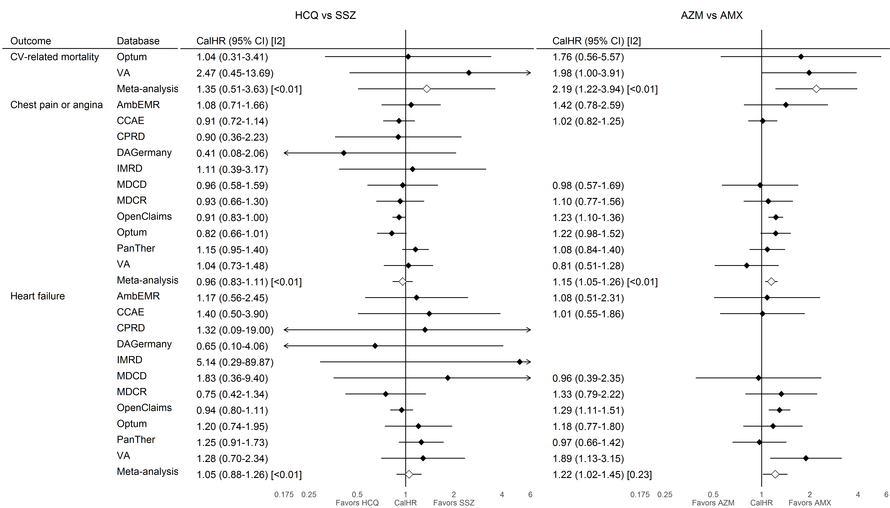

HCQ=hydroxychloroquine; SSZ=sulfasalazine; AZM=azithromycin (plus concurrent hydroxychloroquine exposure); AMX=amoxicillin (plus concurrent hydroxychloroquine exposure); CalHR=calibrated hazard ratio; CI=confidence interval; I2=estimate heterogeneity statistic; AmbEMR=IQVIA Ambulatory EMR; CCAE=IBM Commercial Database; CPRD=Clinical Practice Research Datalink, DAGermany=IQVIA Disease Analyzer Germany; IMRD=IQVIA UK Integrated Medical Record Data; MDCD=IBM IBM Multi-state Medicaid; MDCR=IBM Medicare Supplemental Database; OpenClaims=IQVIA Open Claims; Optum=Optum Clinformatics Datamart; PanTher=Optum PanTherapeutic Electronic Health Record; VA=Veteran’s Health Administration Database. AZM vs AMX comparisons in CPRD, DAGermany, and IMRD did not meet study diagnostic criteria so estimates are not reported.

# **Figure 2. Source-specific and meta-analytic cardiovascular risk estimates for hydroxychloroquine vs sulfasalazine and azithromycin vs amoxicillin new users during on-treatment follow-up**

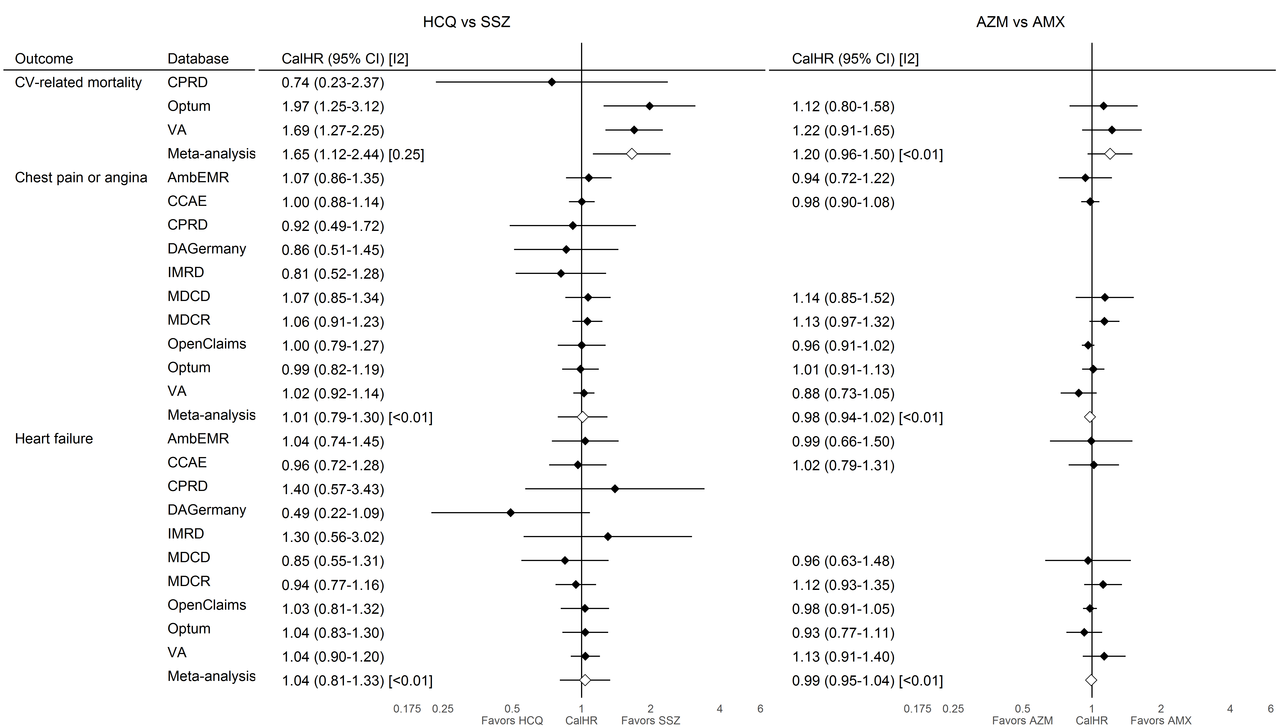

HCQ=hydroxychloroquine; SSZ=sulfasalazine; AZM=azithromycin (plus concurrent hydroxychloroquine exposure); AMX=amoxicillin (plus concurrent hydroxychloroquine exposure); CalHR=calibrated hazard ratio; CI=confidence interval; I2=estimate heterogeneity statistic; AmbEMR=IQVIA Ambulatory EMR; CCAE=IBM Commercial Database; CPRD=Clinical Practice Research Datalink, DAGermany=IQVIA Disease Analyzer Germany; IMRD=IQVIA UK Integrated Medical Record Data; MDCD=IBM IBM Multi-state Medicaid; MDCR=IBM Medicare Supplemental Database; OpenClaims=IQVIA Open Claims; Optum=Optum Clinformatics Datamart; PanTher=Optum PanTherapeutic Electronic Health Record; VA=Veteran’s Health Administration Database. AZM vs AMX comparisons in CPRD, DAGermany, and IMRD did not meet study diagnostic criteria so estimates are not reported. On-treatment follow-up information was not available in the PanTher database.

# **Figure 3. Meta-analytic cardiovascular risk estimates for hydroxychloroquine vs sulfasalazine and azithromycin vs amoxicillin new users during on-treatment during 30-day and on-treatment follow-up**

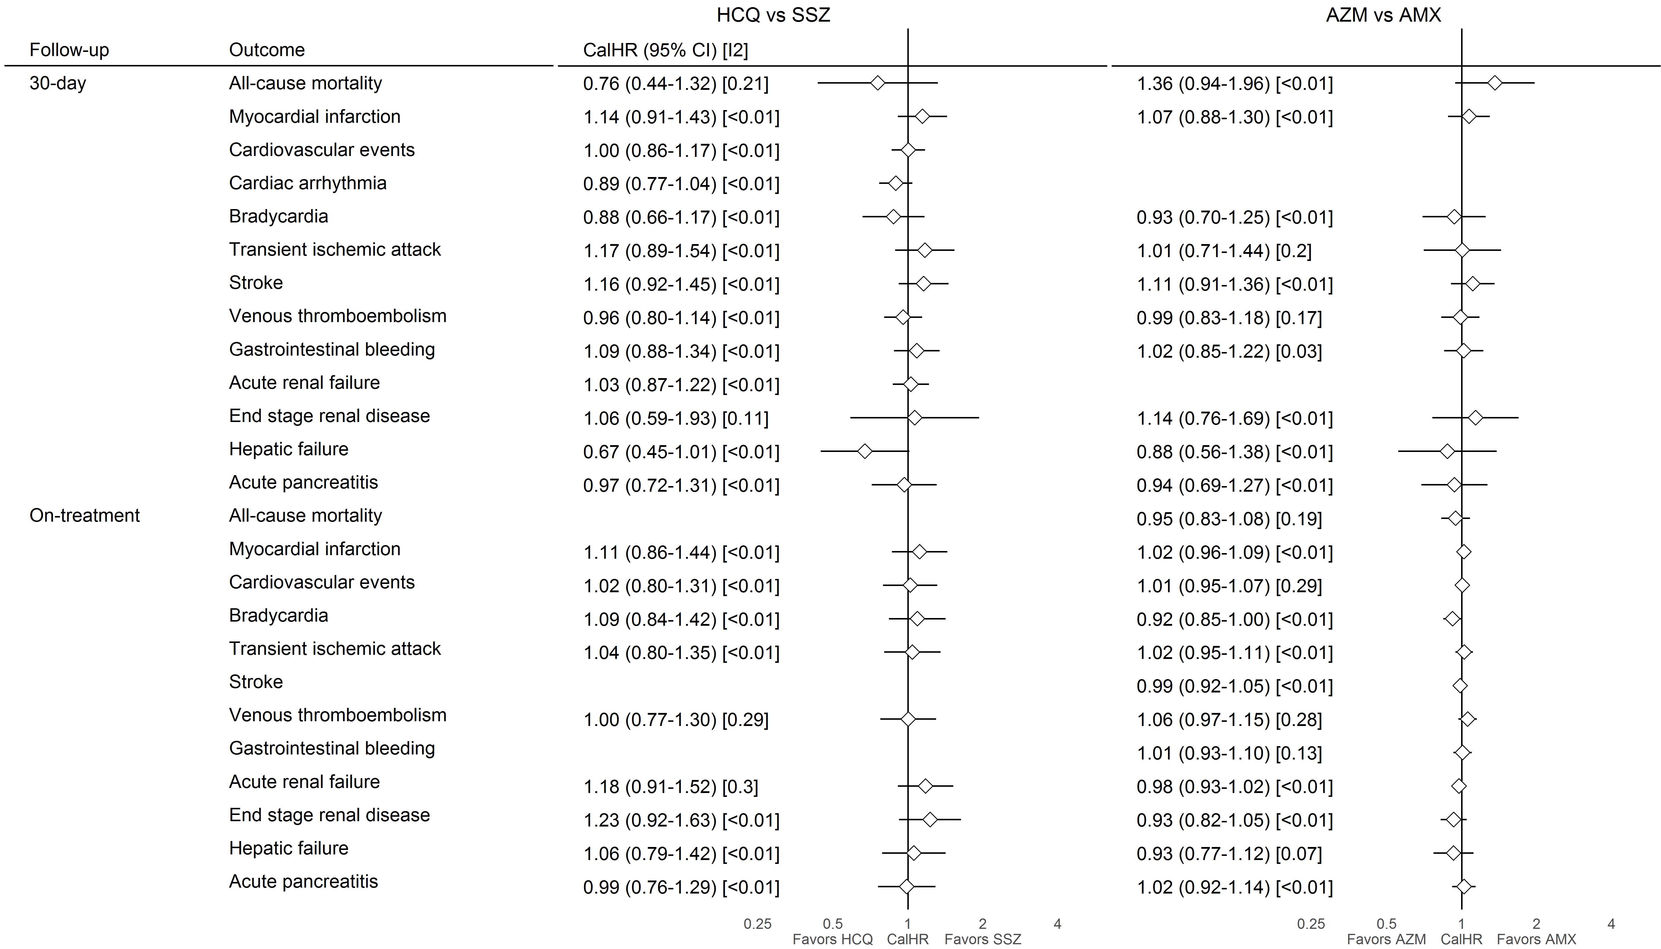

HCQ=hydroxychloroquine; SSZ=sulfasalazine; AZM=azithromycin (plus concurrent hydroxychloroquine exposure); AMX=amoxicillin (plus concurrent hydroxychloroquine exposure); CalHR=calibrated hazard ratio; CI=confidence interval; I2=estimate heterogeneity statistic. Meta-analytic estimates reported where I2<0.4. All database-specific estimates are reported in Appendix Tables S9.1-S9.X